

TECHNICAL DESIGN

Project: Virtualization

Client: Plaintech |  | Filename: | Technical Design v1.0 team 1 Final.docx
Project: Virtualization |  | Version: | 1.0
Author: Willem Westerhof, Pieter Dieleman, Eddy van der Steen, Kjell Zijlemaker, Rodney Lanuzga |  | Date: | 04-1-2014

Document properties

History
Version | Date | Changes(concept/final) | Client | Author(s)
0.1 | 16-9-2014 | Concept | Plaintech | All Teammembers
0.2 | 17-9-2014 | Charts added | Plaintech | All Teammembers
0.3 | 17-9-2014 | Descriptions added | Plaintech | All teammembers
0.4 | 17-9-2014 | Grammer check | Plaintech | Willem Westerhof
0.5 | 23-9-2014 | Changed Archimate diagrams to new versions | Plaintech | Eddy van der Steen
0.6 | 2-10-2014 | Added IP plan and global network topology | Plaintech | Eddy van der Steen
0.7 | 10-11-2014 | Added models for network and database models | Plaintech | Kjell Zijlemaker
1.0 | 04-1-2015 | Final changes made | Plaintech | Willem Westerhof

Approval
This document needs the following signatures of approval:
Name | Role | Autograph | Document Date | Version
Arjen Jansen | Project manager |  | 04-1-2014 | 1.0
CEO/CFO | Client |  | 04-1-2014 | 1.0

Index

Documentproperties 2
History 2
Approval 2
1. Introduction 4
2. Archimate System Model 5
3. Network Design 7
4. Technology model: 8
5. Server Tier Model 9
5.1 Deeper into the layers: 10
6. MySQL DB 11
7. VM Management 12
8. IP Plan 13
9. Data-network 13
10. Backup system 15
11. High Availability 16

1. Introduction

In this document you will find all the technical functionalities for the new virtualization platform as well as the required infrastructure. The technical functionalities also include the models for the network with all needed hardware and software components as required for Plaintech.
This document is spliced in a couple of different parts. In most of these parts you will find a schematic overview and a written explanation. The total sum of this of this document, explains the entire system as intended to be used in the full scale implementation stage. Wherever possible, this system has been used in the proof of concept stage.

2. Archimate System Model

This Archimate model has two layers: the technology and application layer. These two layers are in conjunction with each other, with the sole purpose of defining the newly designed architecture for Plaintech.

As seen in the model below, we first have the technology layer for indicating the servers that will run in support for the applications. As you can see, we have one server node where Debian will run on. In the Debian environment there will be a database that has the purpose to support several applications, higher up in the layer structure.

Higher up in the layer structure you’ll see that there are several services that will help realize the underlying structure. The following services will support the application layer:
- Database service
- Python/Bash service
- KVM Hypervisor service
The hypervisor service is the most important since this will be the foundation for the virtualization platform. As agreed upon, the KVM will be Linux based.

In the application layer, we have selected the applications that will need to run on the server and will trigger another application for execution. The following applications will trigger another:: Webserver → Scripts for the KVM → KVM
Furthermore, the webserver itself will also realize the web interface for the customers that’ll login to manage their servers. Also, the KVM will realize the virtual server that will be the hosting part of the virtual machine.
The last part (and layer) for the Archimate system model are the virtual machines that will be created by the server. These virtual machines will be able to support the following operating systems:
- Debian
- Windows server 2008
- Slackware
- (this could be added to in the future)

The customer will be able to choose the specifications for the host they want to buy. Of course there will be differences in cost per operating system, although this will not be described here.
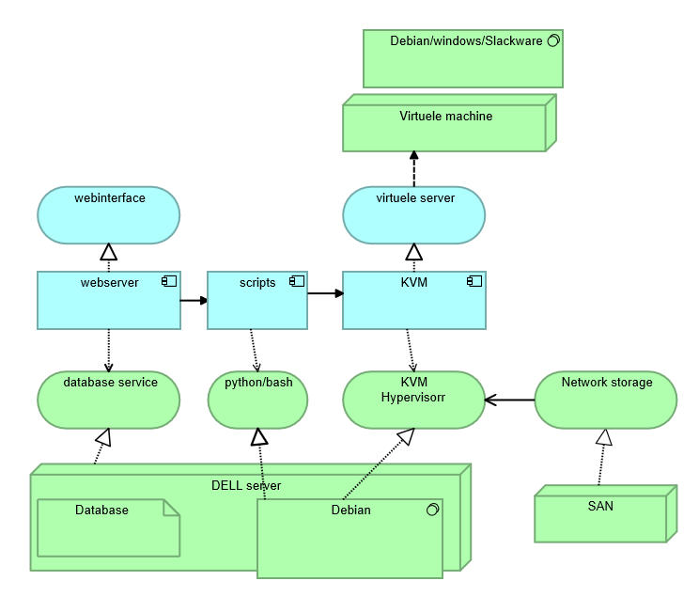

3. Network Design
In the schematic below you can find detailed information about the network setup. All the way on the left side of the diagram there are a number of “clients.” These clients are customers on any kind of devices. These clients can then connect to the Plaintech website to browse on the website and order a server.
The computer that hosts the website is connected to a local area network. Within this network there are 5 categories of machines. First off the webhosting machine, this is the machine that hosts the Plaintech website and communicates with the database and hypervisor machine.
The next part of the network is the database machine. This machine is dedicated to database coverage and making sure all data is processed quickly.
Then there is the backup server. All data and virtual machines that have the daily backup package are backed up to this machine.
Finally there is the hypervisor. This is the machine that creates new virtual machines as requested by the user. Technically this isn’t just one machine, it is a node of servers that combine their power. This greatly improves the flexibility and scalability of the overall system.

The last machine all the way to the right in the diagram is a server node which holds an exact copy of all Virtual servers with the high availability package. This way if anything happens to the Virtual server it can be restored instantly by switching over to the secondary server.
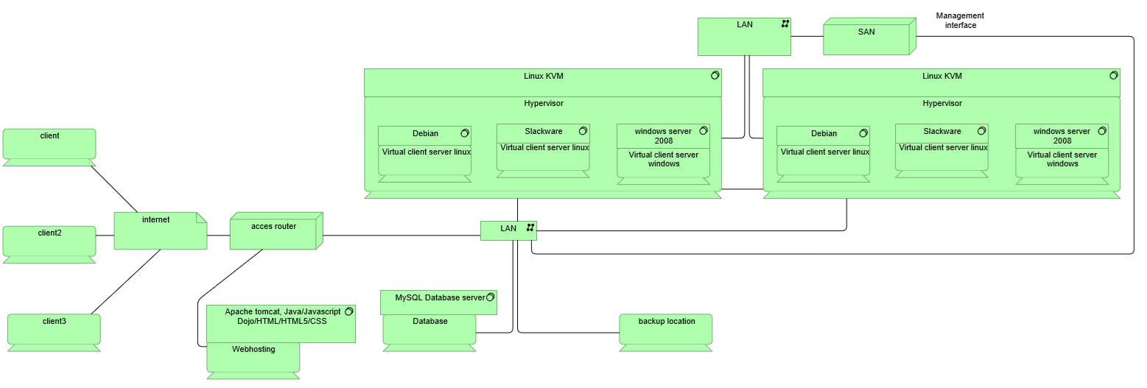

4. Technology model:

The technology model is a small overview of how the technology will flow through the application. For example, all of the logic (and html) is kept in the TomCat container. In the middle of that, there will be JSON (needed with dynamic content), but this can also go straight to the JDBC for making the connection to MySQL.
The data will go back through the JDBC connection and will go back, either by JSON, or without if preferred. The servlets will maintain some control for the data that will be send to LibVirt, for example, the scripts that LibVirt will need to receive for making new connections to VM’s.

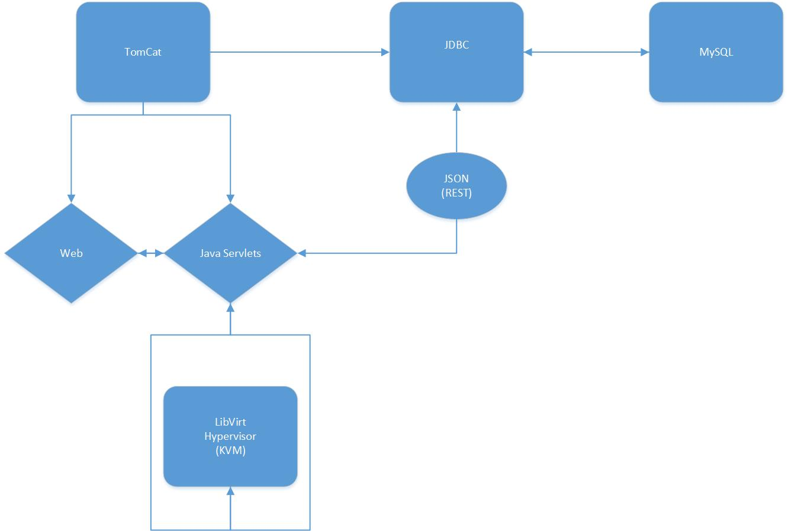

5. Server Tier Model
In the Server Tier model, we see 3 tiers. These tiers will make sure that all the data will be in its designated place. The presentation tier will be responsible for showing all the generated data with the designated servlets. The business logic tier will be responsible for the logic part of the data, coming in from the database. All the checks and complicated things (such as objects) will be done here.
The Infrastructure tier will be responsible for making the connection to the database and getting the data for the data logic tier.
If done correctly, all the data will be nicely encapsulated and the server tier will be easy to manage and expand.

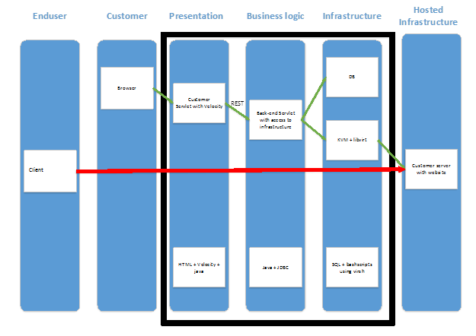

5.1 Deeper into the layers:
In the diagram showed next, we zoomed into the layers a little deeper. Here, the firewalls and servlets are shown that will power the application. There can also be several containers for improvement of the security, but also the expandability. On top of that, the servlets will also communicate with RESTFUL services.

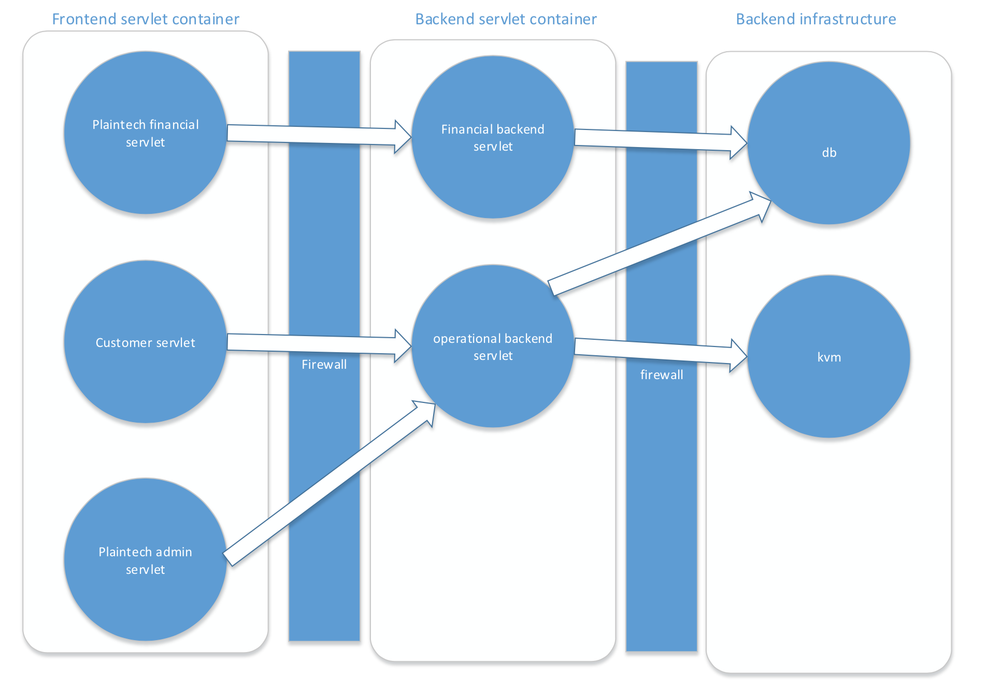

6. MySQL DB
At the MYSQL diagram we can see that the logical data structure has taken a physical place. Eventually when managed, one user has one or many VM’s that he/she can work with. All the data from the VM will be managed from there. We also show the storage volumes and pools as well as the net addresses. This is part of the SAN system for distributing hard disk space.

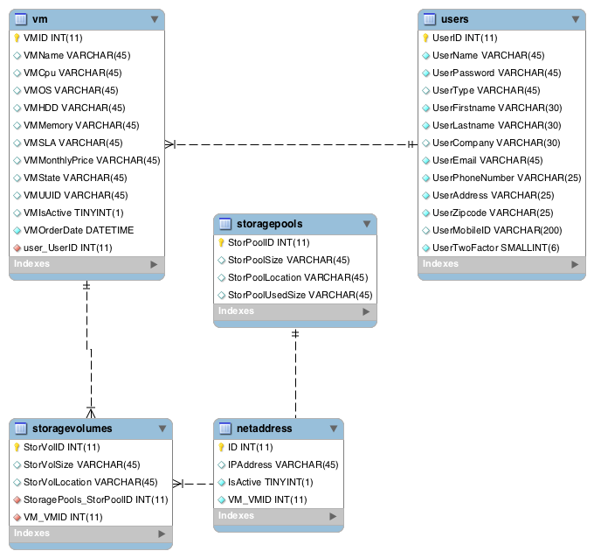

7. VM Management

The VM management is a bit like the server tier model. This particular case for the VM management is creating a new VM. As seen below, the user will need to go to the presentation servlet for ordering a server. When done, the business logic makes sure that this data will be processed. The business logic will then check if the server can be created. If done and everything goes well, the servlet will make a request to the KVM to create the server. If a response is given from the KVM, the new information will be written to the database. Of course, all the data will be presented to the customer now. Editing and Deleting Virtual machines Function in a similar way.
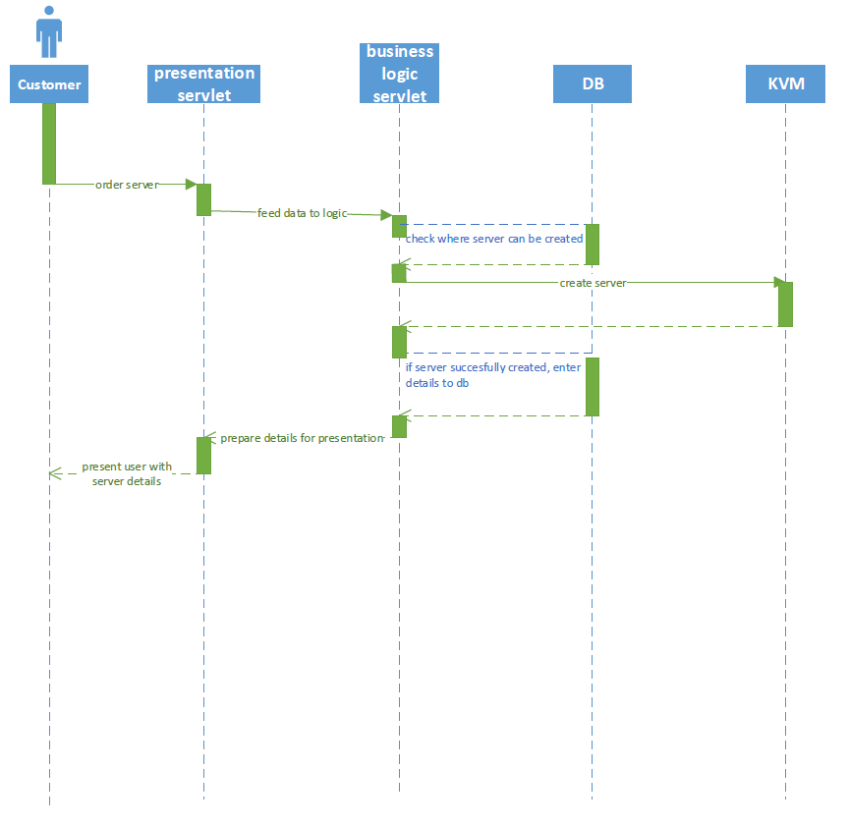

8. IP Plan

Seeing as Plaintech has at least 50.000 customers, with at least 1 server each, there must be at least 65.000 IP addresses available in the network infrastructure. As Plaintech expects a 100% growth within 5 years, even these 65.000 IP addresses is not enough. This is a massive amount, and must be segmented properly to ensure the network won’t be suffering from congestion and traffic does not slow down.

Subnetting:
To be able to use all of the IP addresses required, we need a class A network with several different subnets. A class A network has a total maximum number of 16,777,216 addresses minus 2.

There should first of all be a division between the customer servers and the virtualised servers that Plaintech uses for their own business ends (webservers, databases etc). On top of that, both of these ranges should be separate from the range of physical servers on which KVM runs.

As the servers will be put in 19" racks with a height of 47U, there will be 20 servers with roughly 100 virtual machines each in a rack. This means that each rack needs about 2000 IP addresses. 2000 IP addresses equals a /21 network per rack. The initial situation will require 30 racks each with their own /21 subnet. As all of these IP's will be public IP's, these should be requested from the third party ISP that provides connectivity to the internet.

9. Data-network

All of the physical hosts should be interconnected to the SAN on a second, completely separate, network. This means that all 556 initial hosts should be connected to all initial SAN devices. This network is entirely connected with Fiber optics, meaning that each physical server has to be connected to the SAN via Fiber HBA. On the following diagram, the SAN is depicted as a cloud network without IP addresses. This is to ensure that the concept of a SAN remains true to its nature as the disks are shared at block level instead of being shared at the file system level.
Additionally, since it's on fiber optics and IP-less, there is no encapsulation of any data between the SAN and the physical servers, which further increases the throughput of all data traffic.

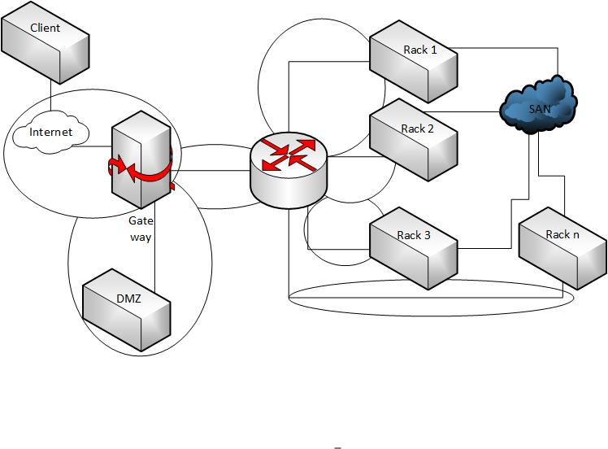

10. Backup system
For all users who have chosen the silver or gold service level a daily offsite system backup will be in place. This daily backup will be located at the SAN in the secondary datacentre. Once each day whenever the system is least busy, (this exact time is to be determined,this will most likely be somewhere around 2pm and 3 pm) the system will start it’s backup procedure. This means sending all relevant data of systems with a silver or higher SLA towards the SAN at the secondary datacentre.

When a virtual machine is created, the SLA is saved in the database. By doing a query on this database all uuuid’s with a silver or gold SLA are set in an array. This array is then used in a bash script which uses a loop to loop through the different uuuid’s and make a backup of this specific machine. This backup is send to the secondary datacentre for saveguarding purposes. When a VM is deleted or the SLA Is changed the database entry will also be changed and the script will no longer (or from this day onward) make a backup of this machine. This bash script will run on a daily basis in order to comply with the Daily backup service.

11. High Availability
For those users with a gold service level we offer high availability. This means their servers will be up in 99,99% of the time. We achieve this by having a secondary datacentre where all systems with gold service level are also running and updating live statistics. If for some reason one of these servers or the entire datacentre shuts down, the traffic will automatically be rerouted to this secondary datacentre thereby giving those users with a gold service level a 99,99% uptime. Below you will find a diagram of the intended power supply and fire suppression with redundancy to make sure the datacentres stay online.
